Highly Available Web Application on AWS (VPC + ALB + ASG)
1. Project overview
Goal: Deploy a simple web application running on EC2 instances in private subnets, fronted by an Application Load Balancer (ALB), with an Auto Scaling Group (ASG) maintaining at least two instances across multiple Availability Zones.
Key objectives:
- Design a production-style network using a custom VPC.
- Separate public and private subnets across AZs.
- Use an internet-facing ALB to expose the app.
- Run EC2 instances only in private subnets.
- Use an ASG for high availability and self-healing.
- Secure outbound access from private subnets via NAT Gateway.
All resources were created in a single AWS region (e.g., us-east-2).
2. High-level architecture
Traffic flow:
- Users access the application via the ALB DNS over HTTP.
- The ALB, deployed in public subnets, forwards traffic to a target group.
- The target group contains EC2 instances running in private subnets across two AZs.
- EC2 instances use a NAT Gateway in a public subnet for outbound internet access (e.g., OS updates, package installs).
- An Auto Scaling Group ensures at least two instances are always running and replaces unhealthy ones automatically.
This design demonstrates high availability, fault tolerance, and good security practices.
3. Implementation steps
3.1 VPC and subnet design
What I did
- Created a custom VPC with CIDR block 10.0.0.0/16.
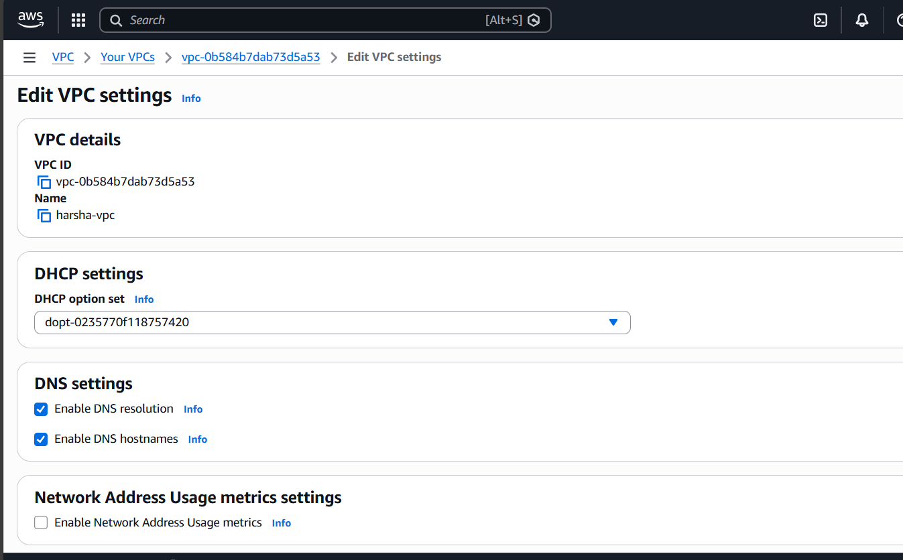
- Created four subnets across two Availability Zones:
  - public-subnet-1 → 10.0.1.0/24 (AZ1)
  - public-subnet-2 → 10.0.2.0/24 (AZ2)
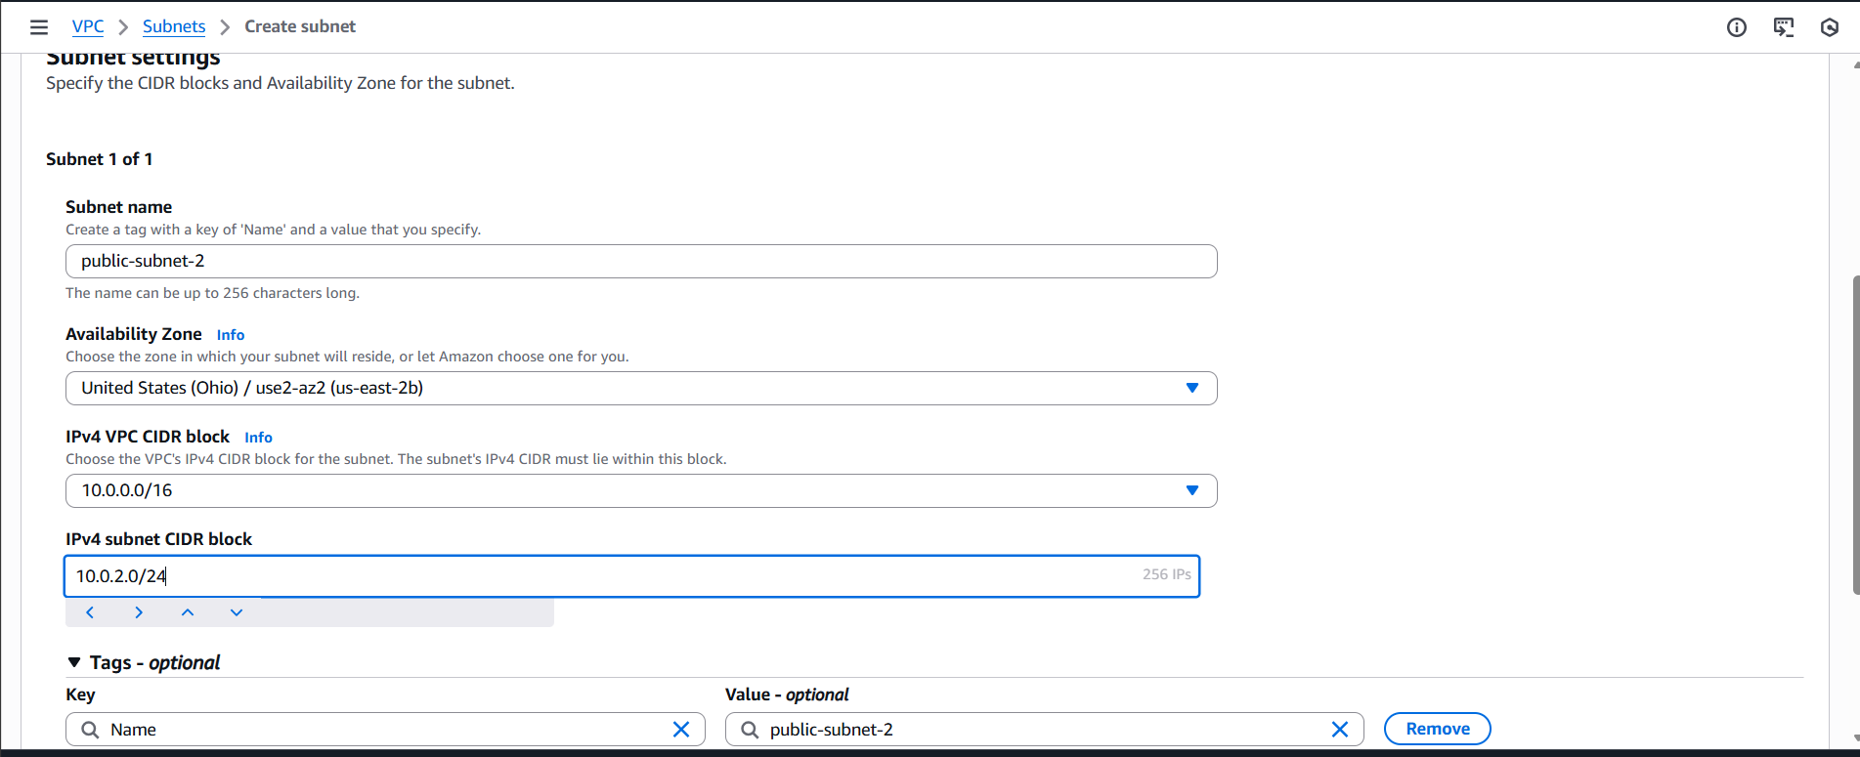
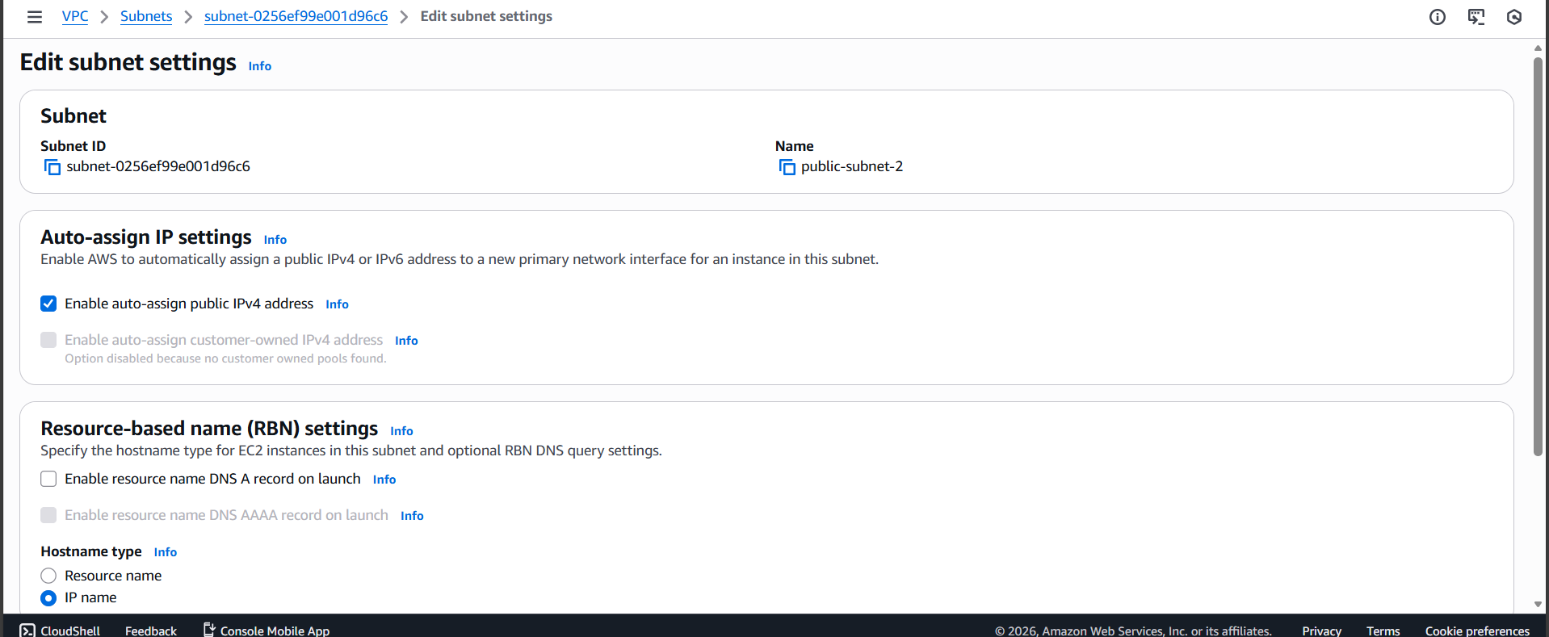
  - private-subnet-1 → 10.0.3.0/24 (AZ1)
  - private-subnet-2 → 10.0.4.0/24 (AZ2)
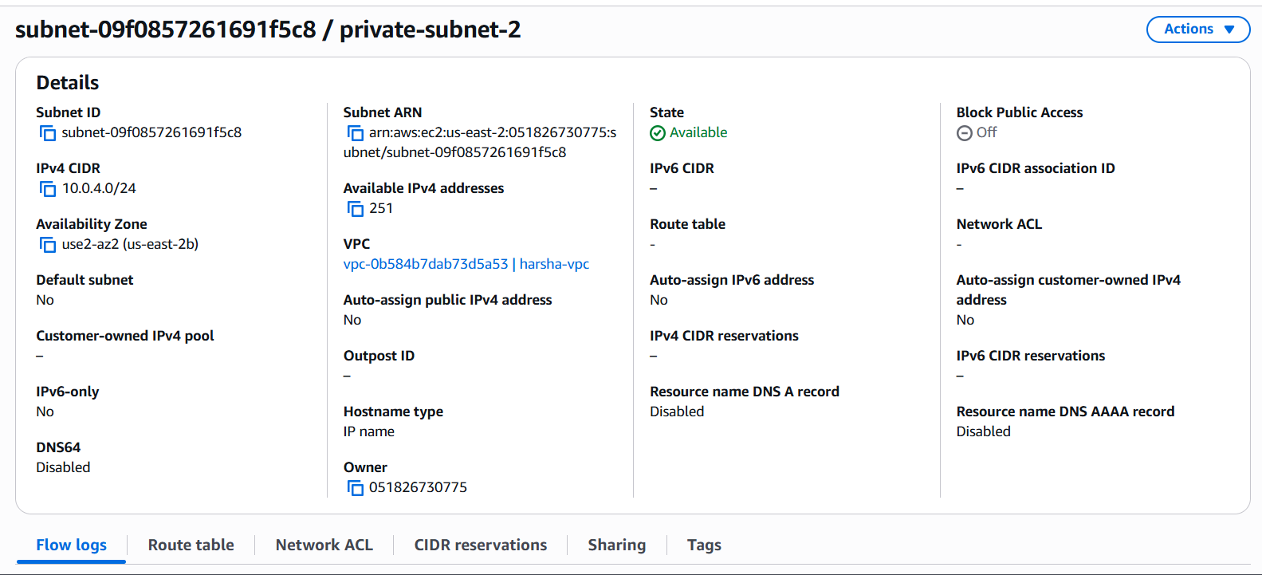
- Enabled auto-assign public IP only on the public subnets.
Why:
- A dedicated VPC provides network isolation and full control over IP addressing.
- Splitting into public and private subnets across AZs enables:
  - High availability (multi-AZ).
  - Defense-in-depth, where only necessary components are internet-facing.

3.2 Internet Gateway and NAT Gateway
What I did
- Created and attached an Internet Gateway (IGW) to the VPC.
- Created a NAT Gateway in public-subnet-1 with an Elastic IP.
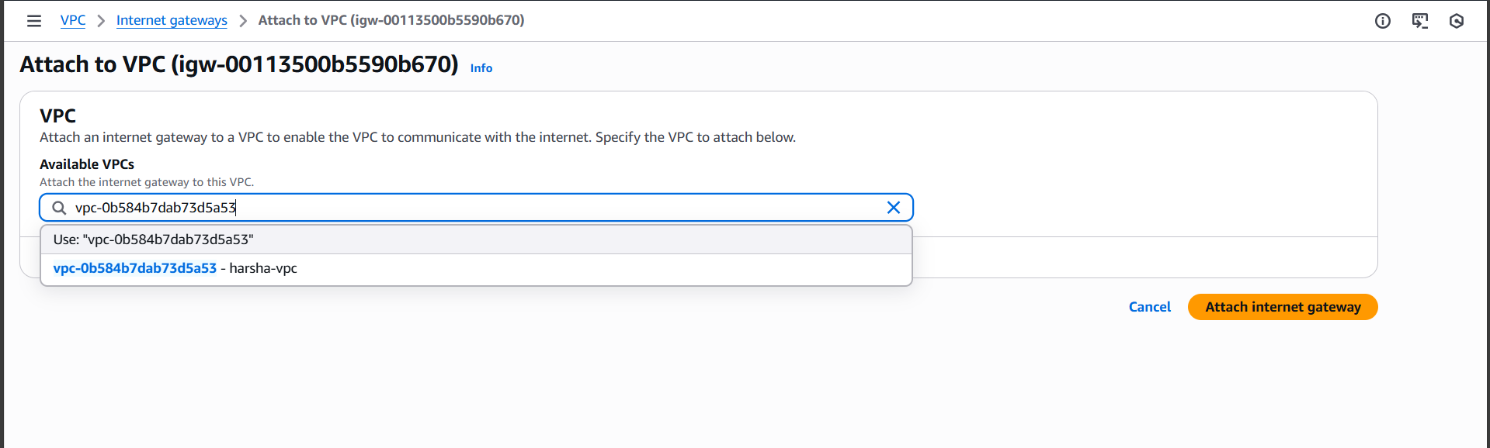

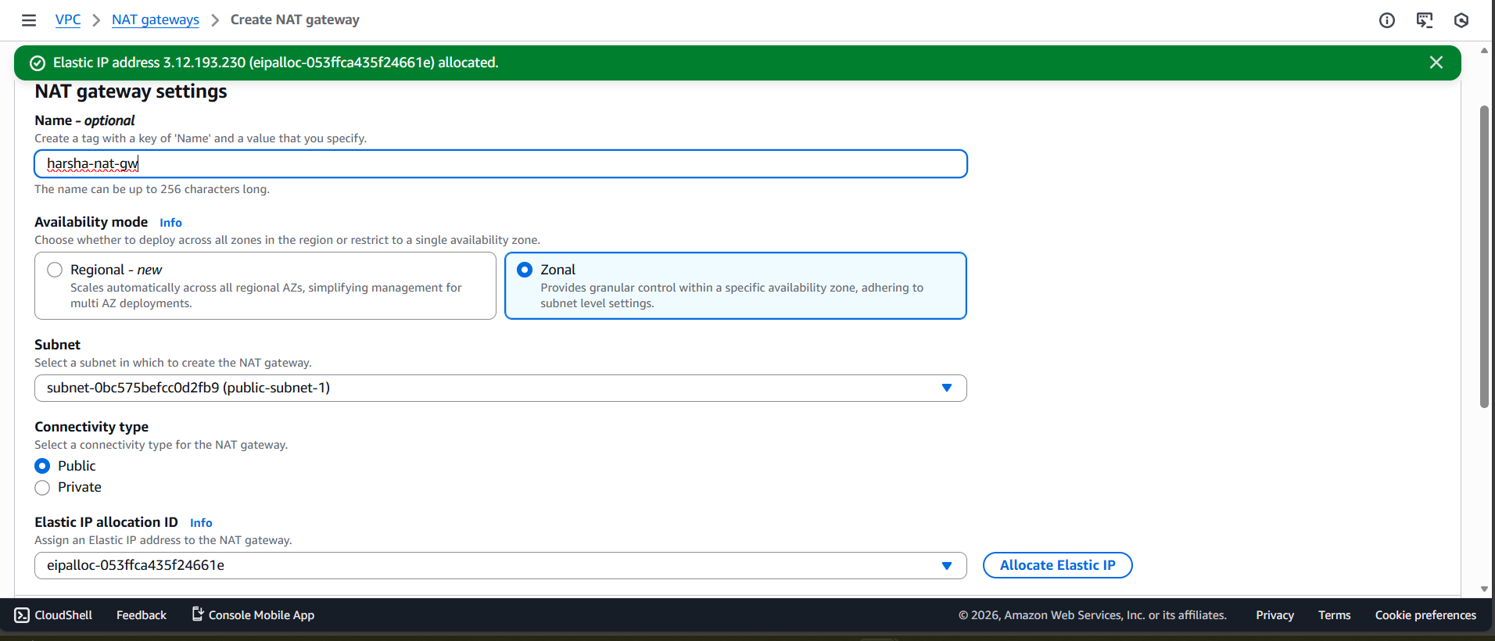
Why
- The IGW allows resources in public subnets (ALB, NAT) to communicate with the internet.
- The NAT Gateway allows private subnet instances to initiate outbound connections (e.g., yum update, package installs) without being directly reachable from the internet, improving security.

3.3 Route tables
What I did
- Created a public route table:
  - Route: 0.0.0.0/0 → Internet Gateway
  - Associated with public-subnet-1 and public-subnet-2.
  - Now anything in those subnets can reach the internet (if it has a public IP).

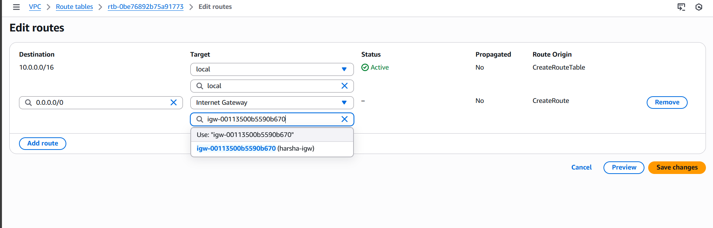

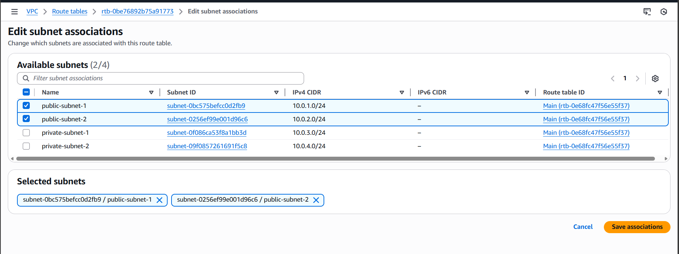
- Created a private route table:
  - Route: 0.0.0.0/0 → NAT Gateway
  - Associated with private-subnet-1 and private-subnet-2.
  - The private subnets can reach the internet outbound only via NAT.
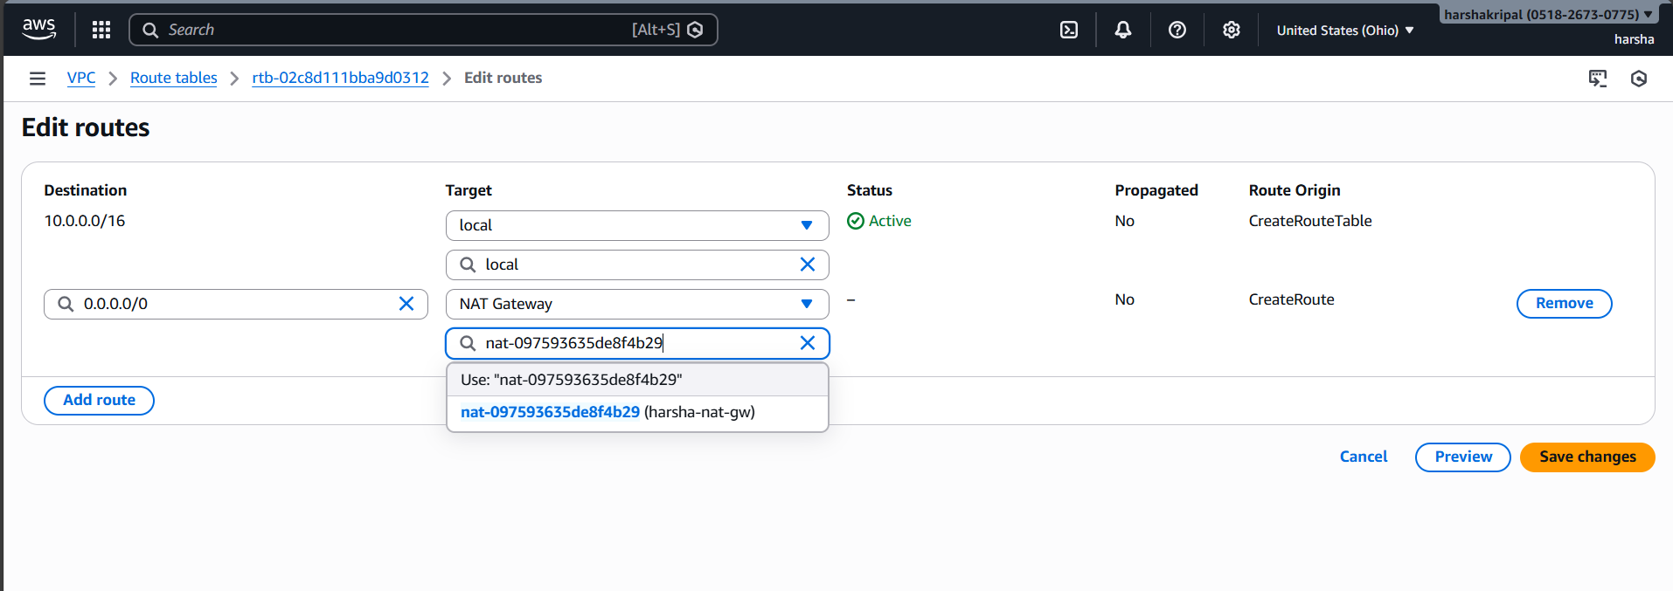

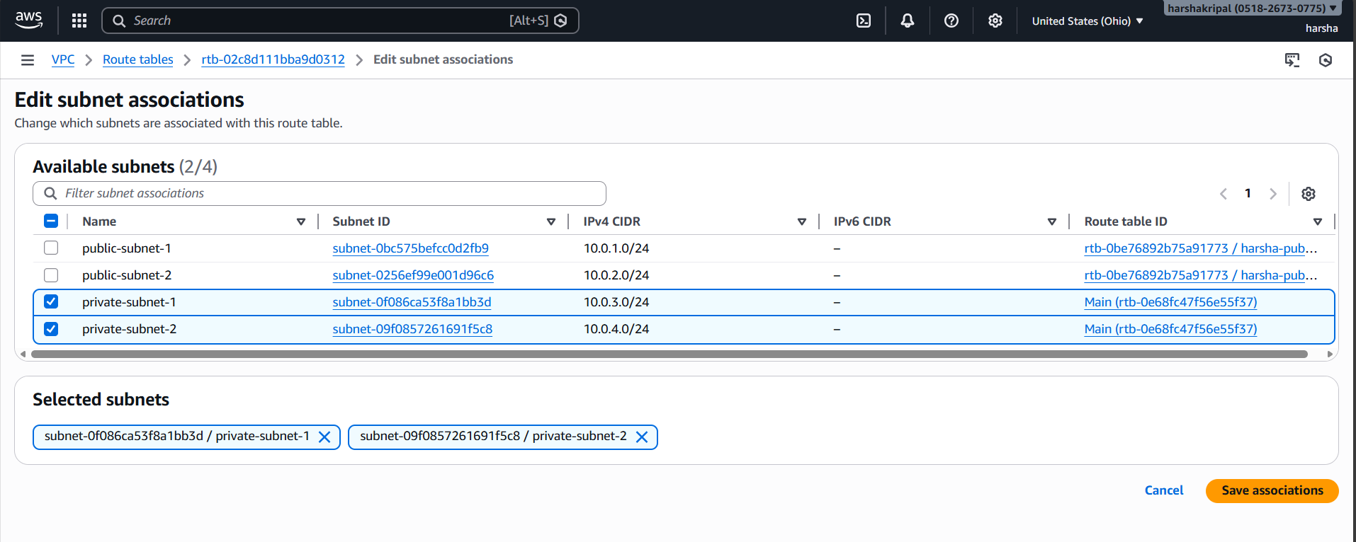
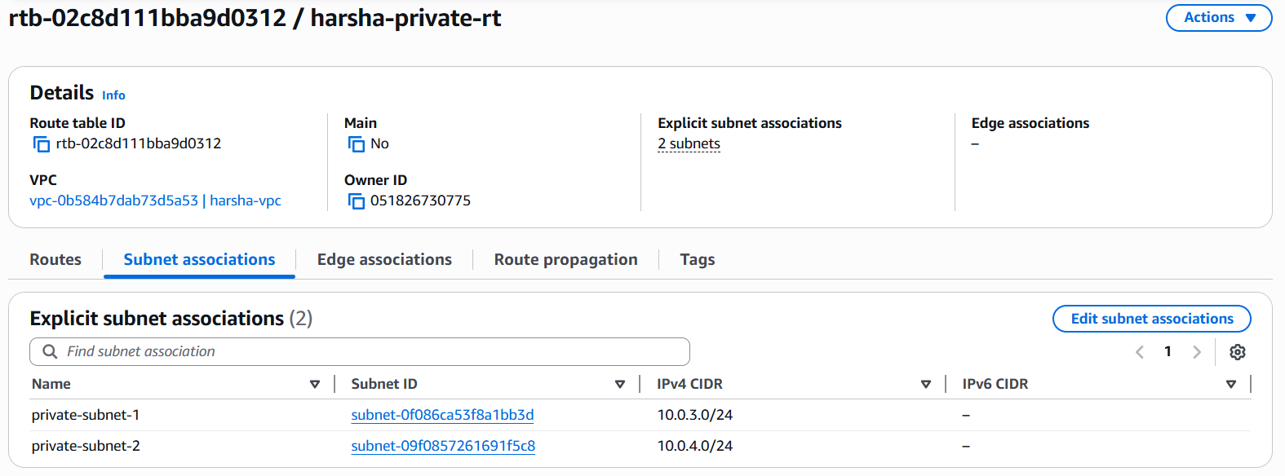
Why
- Public subnets need direct internet access for the ALB and NAT Gateway.
- Private subnets should only have outbound internet access via NAT, not direct inbound access, aligning with best practices for application servers.
3.4 Security groups
What I did
- ALB security group (alb-sg):
  - Inbound: HTTP (80) from 0.0.0.0/0.
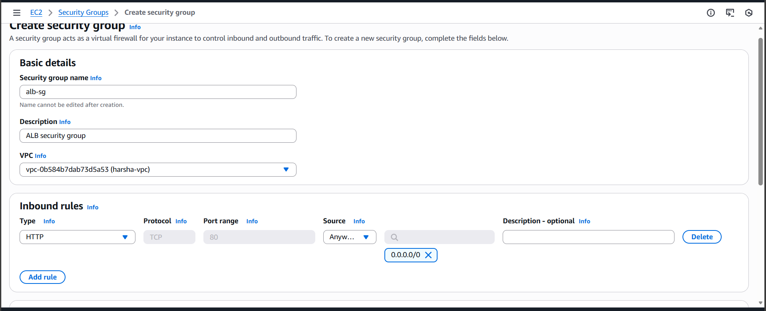
- EC2 security group (ec2-sg):
  - Inbound: HTTP (80) from alb-sg only this means only the ALB can talk to your EC2 on port 80.
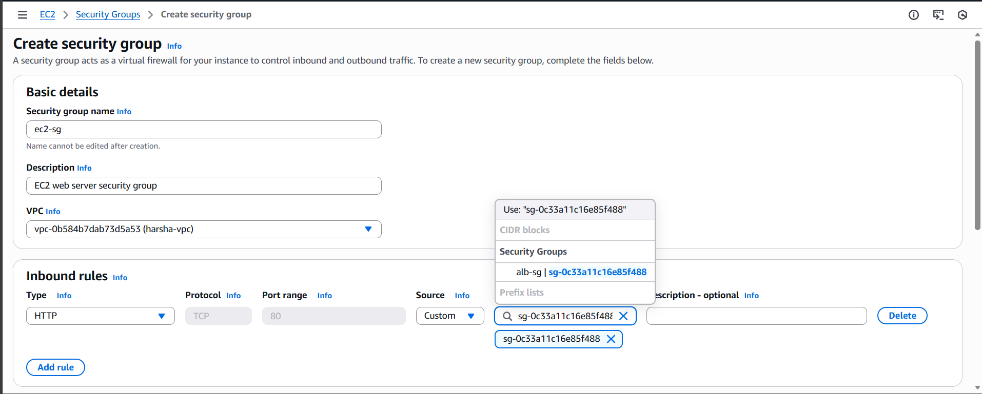
- Outbound rules left as default (allow all) for both.

Why
- The ALB must be reachable from the internet on port 80.
- EC2 instances should not be directly accessible from the internet; only the ALB is allowed to reach them.
- This enforces the principle of least privilege and cleanly separates public entry points from private compute.

3.5 Launch template (EC2 configuration)
What I did
- Created a Launch Template (ha-web-lt) with:
  - AMI: Amazon Linux 2.
  - Instance type: t3.micro / t2.micro.
  - Security group: ec2-sg.
  - No public IP assignment.
  - User data:
yum update -y
yum install -y httpd
systemctl enable httpd
systemctl start httpd
echo "Healthy from $(hostname)" > /var/www/html/index.html
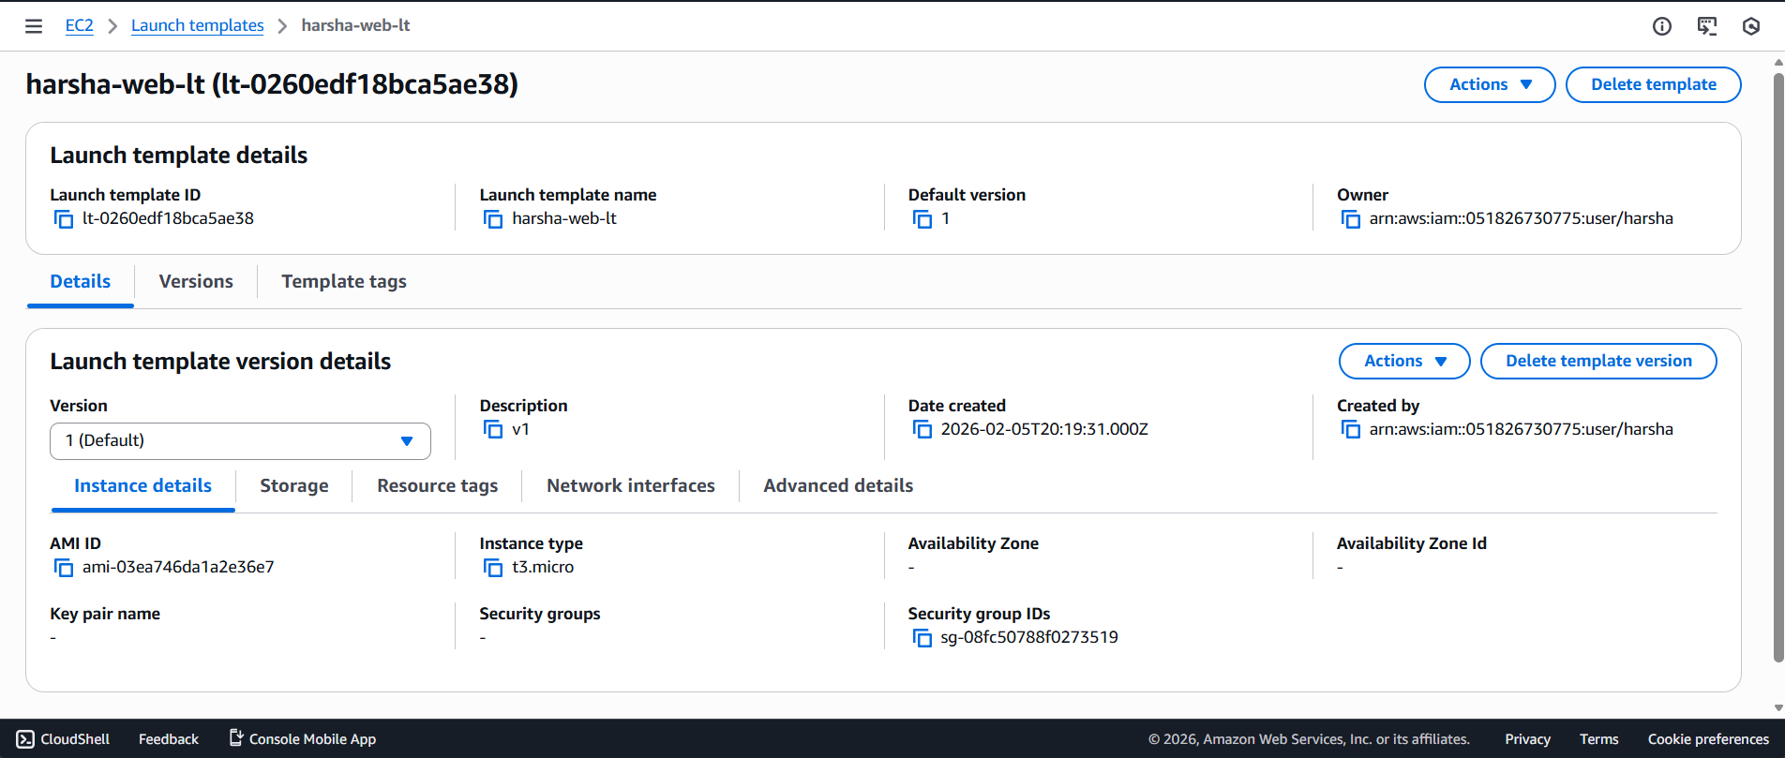
Why
- The launch template standardizes instance configuration and makes it easy for the ASG to create identical instances.
- The user data script automates web server installation and exposes a simple health page, ensuring instances are ready to serve traffic immediately after launch.

3.6 Target group and Application Load Balancer
What I did
- Created a target group (ha-tg) for instances:
  - Protocol: HTTP
  - Port: 80
  - Health checks: HTTP on /.
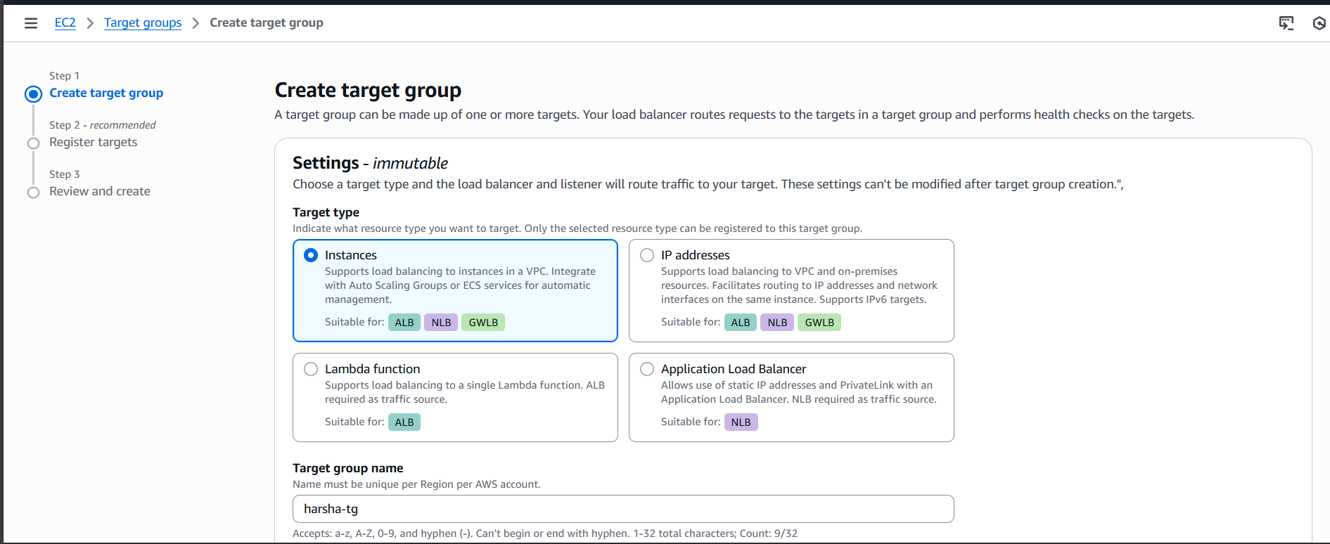
- Created an Application Load Balancer (ha-alb):
  - Scheme: Internet-facing.
  - Subnets: public-subnet-1, public-subnet-2.
  - Security group: alb-sg.
  - Listener: HTTP (80) forwarding to ha-tg.
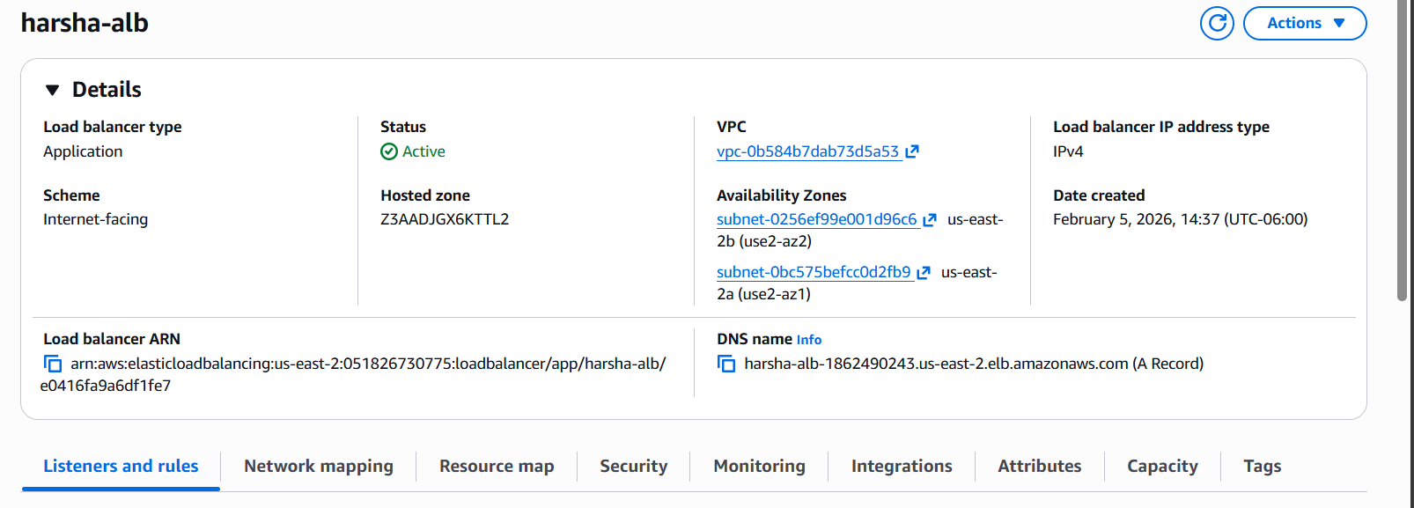
Why
- The ALB provides layer 7 load balancing, distributing traffic across instances in multiple AZs.
- Health checks ensure only healthy instances receive traffic.
- Using a target group decouples the ALB from specific instances and integrates cleanly with the ASG.

3.7 Auto Scaling Group
What I did
- Created an Auto Scaling Group (ha-asg) using the launch template:
  - VPC: ha-vpc.
  - Subnets: private-subnet-1, private-subnet-2.
  - Attached to the ALB via target group ha-tg.
  - Desired capacity: 2.
  - Minimum capacity: 2.
  - Maximum capacity: 4.
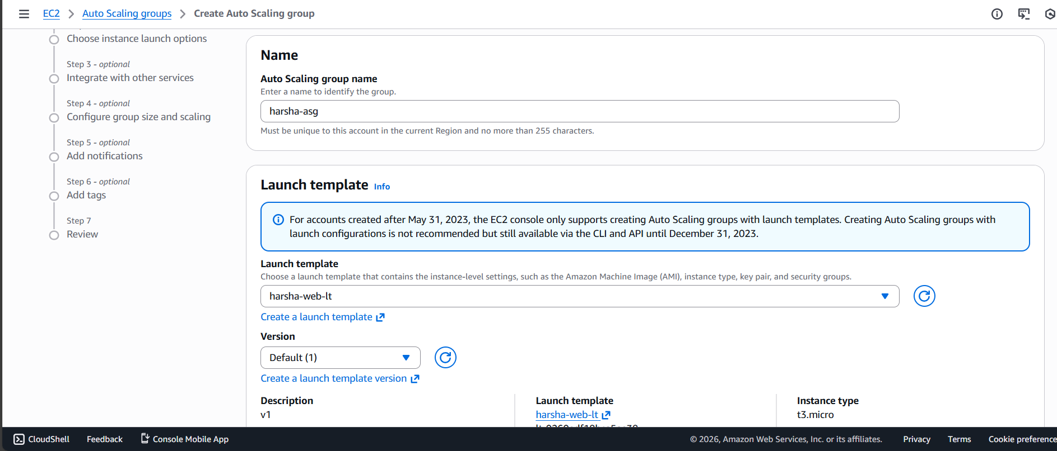

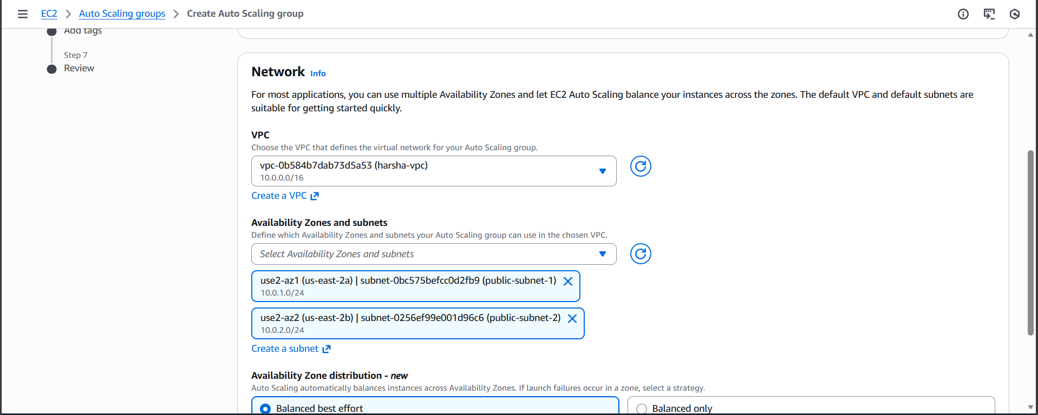
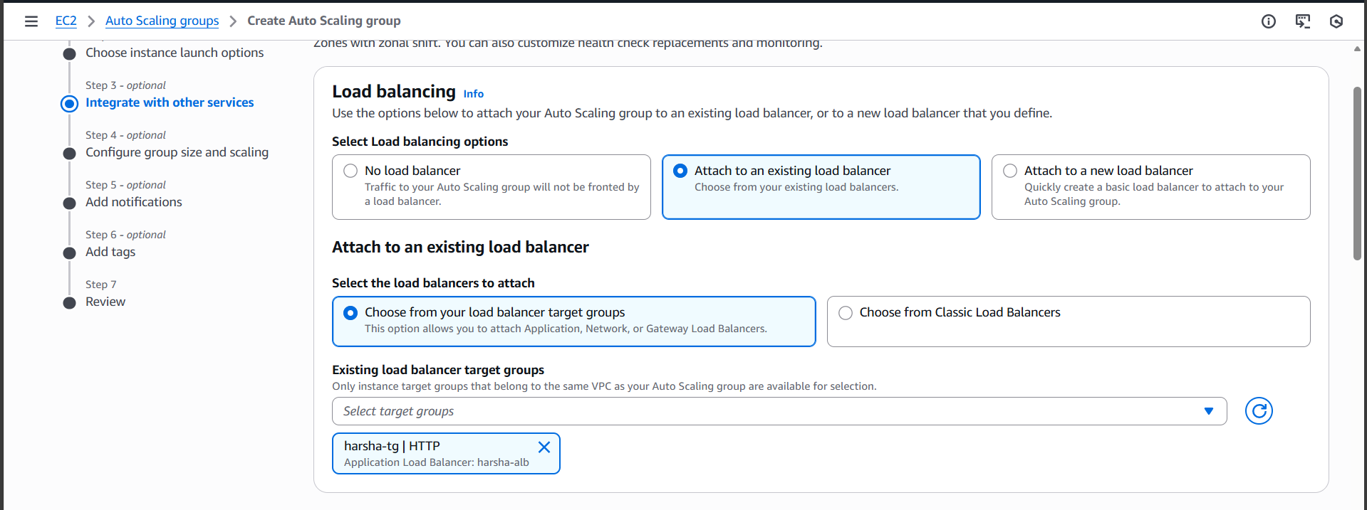

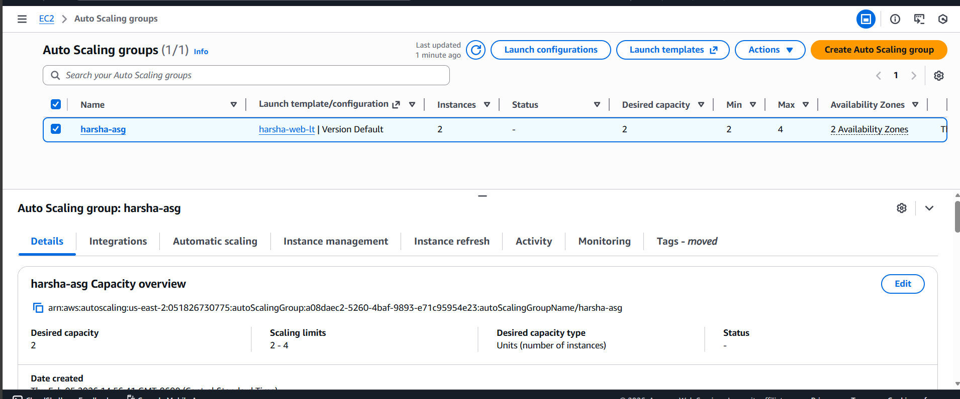
Why
- The ASG ensures high availability by maintaining at least two instances across two AZs.
- If an instance fails or is terminated, the ASG automatically replaces it.
- This reflects real-world self-healing infrastructure and elasticity.

3.8 Validation and testing
What I did
- Verified:
  - Two EC2 instances running in private subnets.
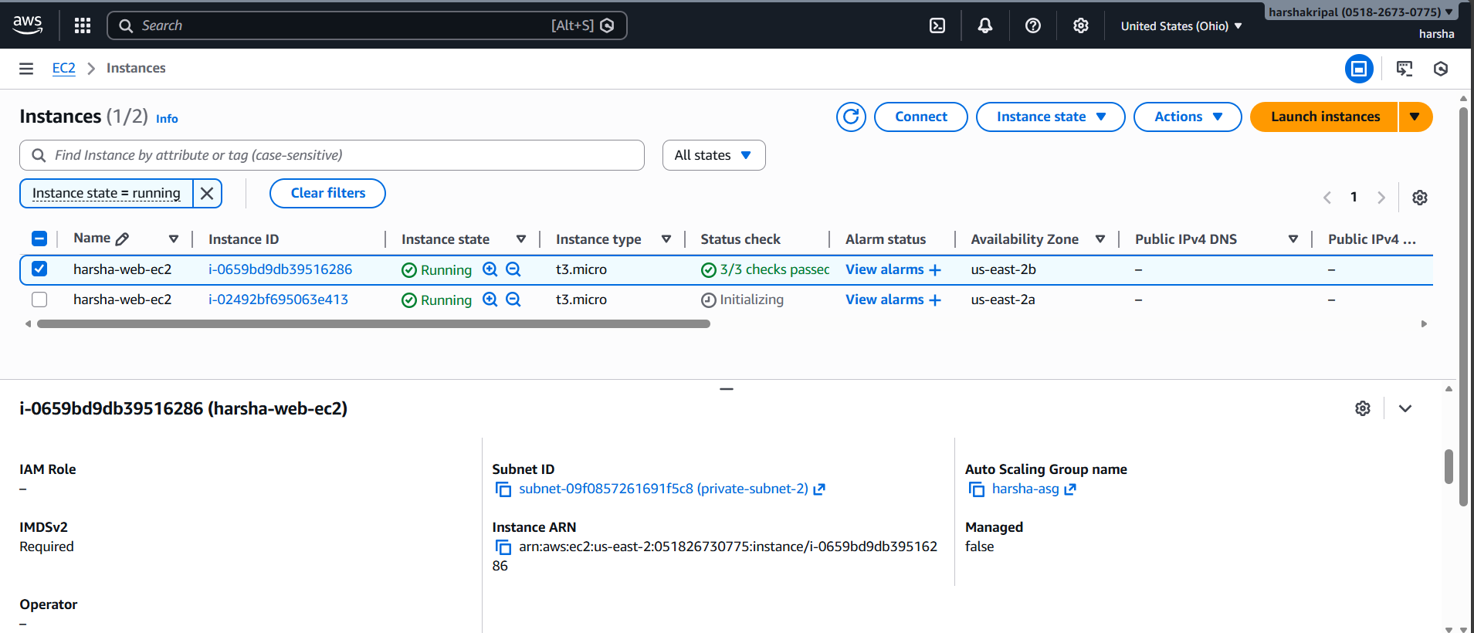
  - Both instances registered as healthy in the target group.
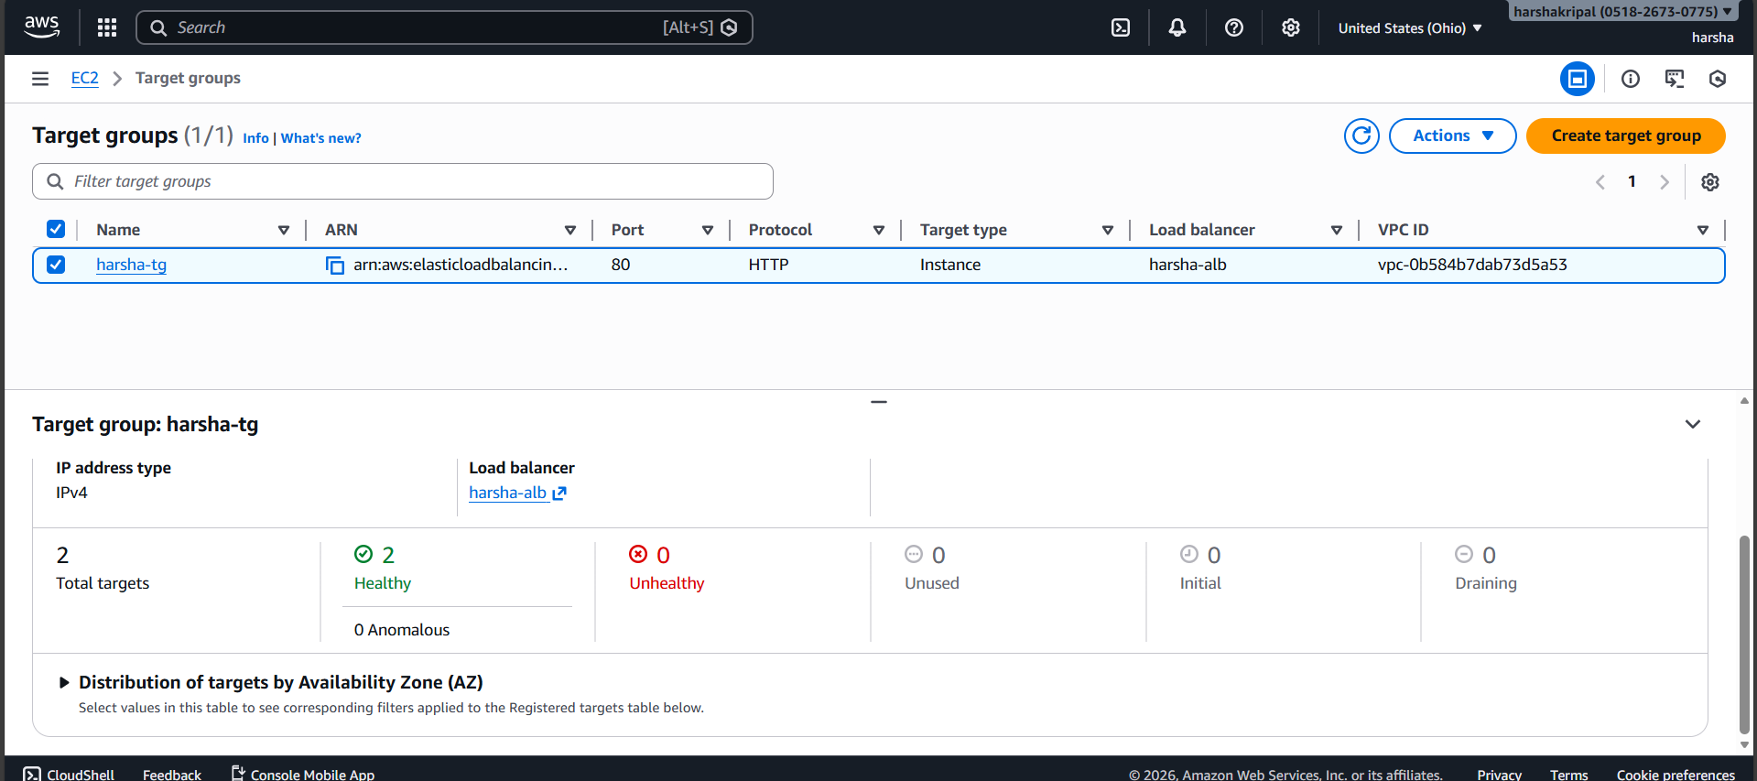
- Accessed the application using the ALB DNS name over HTTP.
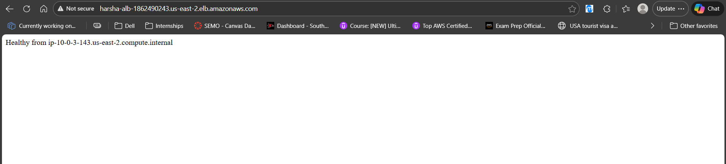
- Refreshed multiple times and observed different hostnames in the response, confirming load balancing.
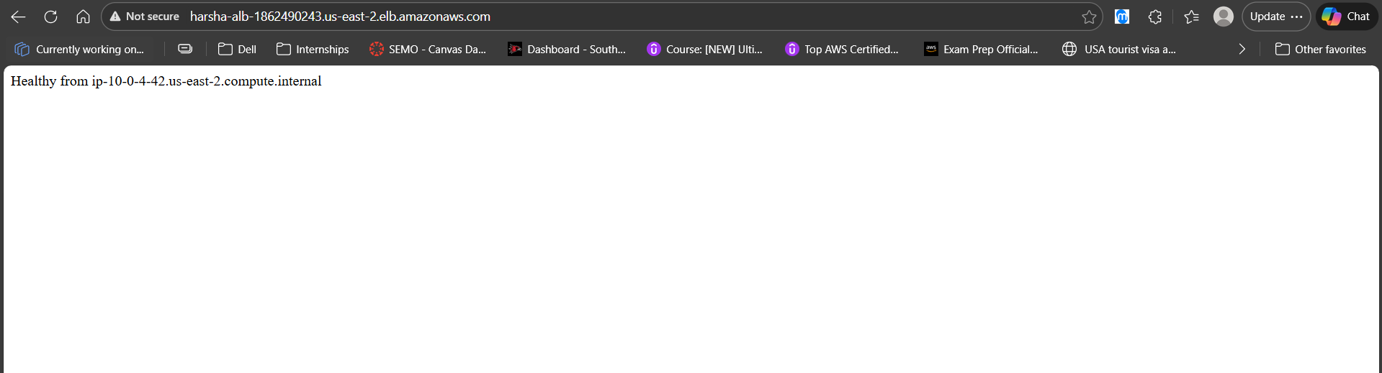

- Terminated one instance manually and confirmed:
  - The ASG launched a replacement instance.
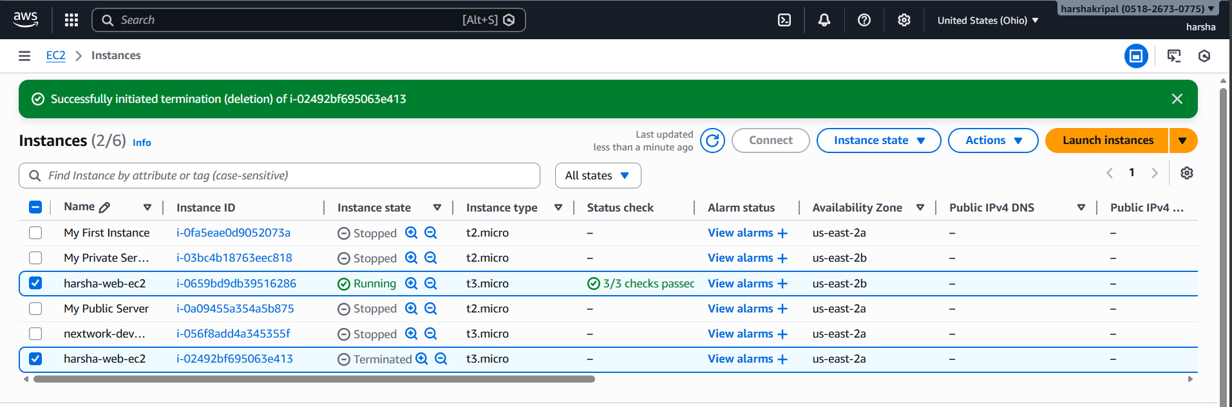
  - The application remained available via the ALB.
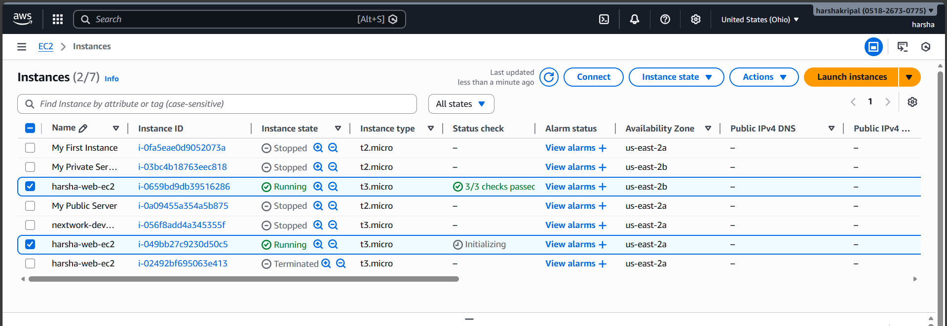

Why
- Validating both normal and failure scenarios is essential to confirm high availability, resilience, and correct configuration.
4. Issue encountered: instances in public subnets instead of private
4.1 Problem
During validation, I noticed that the EC2 instances launched by the Auto Scaling Group were appearing in public subnets instead of the intended private subnets.
This contradicted the design goal of keeping application servers private and indicated a misconfiguration.
4.2 Root cause
I investigated several possibilities:
- Route tables and subnet associations
  - Confirmed that:
    - Public subnets were associated with the public route table (IGW route).
    - Private subnets were associated with the private route table (NAT route).
  - These were correctly configured.
- Auto-assign public IP settings
  - Verified that private subnets did not auto-assign public IPs.
- Auto Scaling Group subnet selection
  - On reviewing the ASG configuration, I found that the ASG was configured to launch instances in:
    - public-subnet-1
    - public-subnet-2
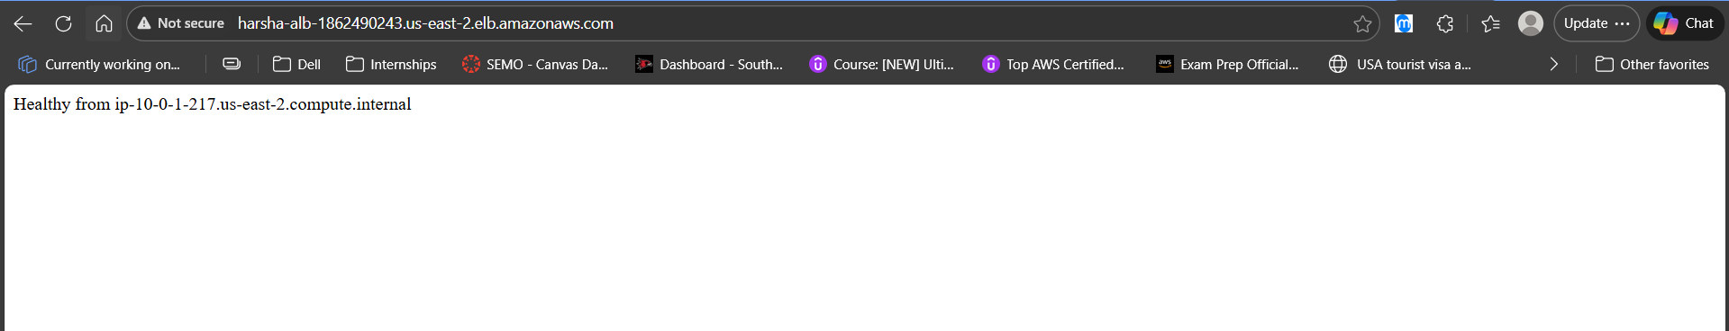
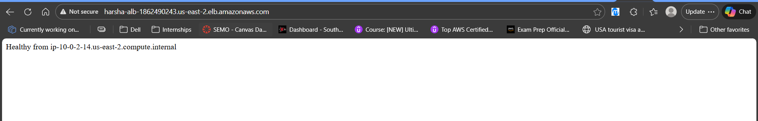
  - Instead of:
    - private-subnet-1
    - private-subnet-2
Conclusion: The root cause was a misconfiguration in the Auto Scaling Group, where public subnets were selected instead of private subnets.
4.3 Fix
To resolve the issue:
- Opened the Auto Scaling Group (ha-asg) in the EC2 console.
- Edited the ASG configuration and updated the Network section to use:
  - private-subnet-1
  - private-subnet-2
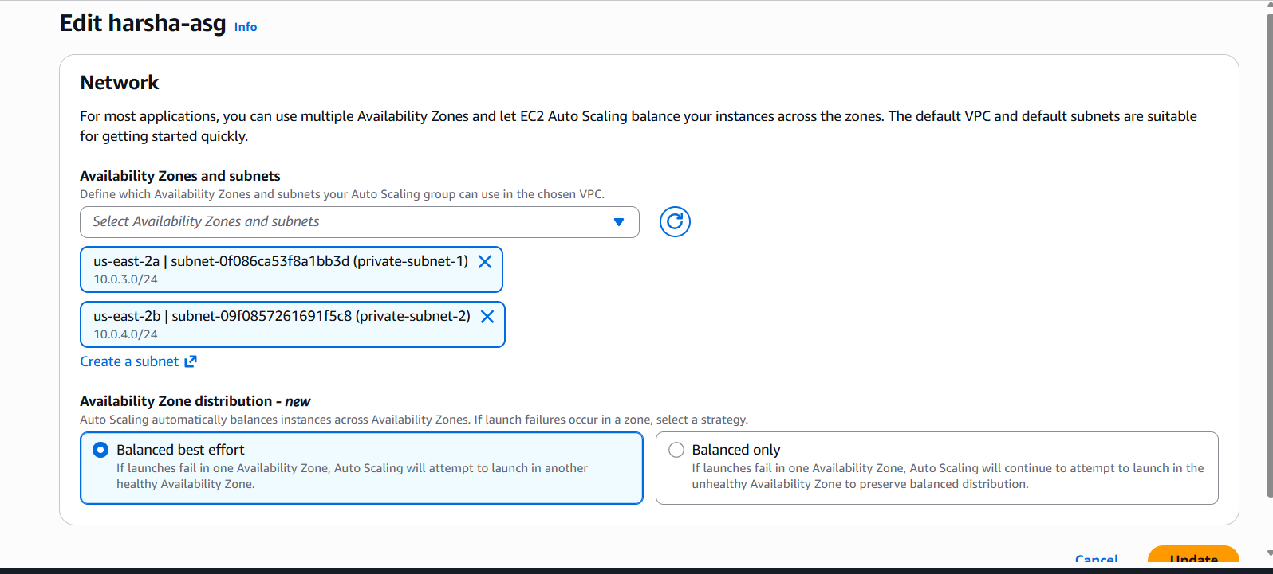
- Saved the changes.
- Terminated the existing instances that were running in public subnets.
- Observed the ASG automatically launch new instances in the correct private subnets.
- Re-validated:
  - Instances were now in private subnets with no public IPs.
  - The application remained reachable via the ALB.
5. Lessons learned
5.1 Subnet selection in Auto Scaling Groups is critical
This issue reinforced that:
- The subnets selected in the ASG directly determine where instances are launched, regardless of naming.
- It is important to verify subnet IDs and associations, not just rely on names, when configuring ASGs.
5.2 Clear mental model of public vs private subnets
This project deepened my understanding that a subnet is effectively:
- Public if it has a route to an Internet Gateway.
- Private if it only has a route to a NAT Gateway (or no internet route).
This clarified the difference between “public/private by name” and “public/private by routing.”
5.3 Debugging and validation mindset
The problem taught me to:
- Systematically validate:
  - Route tables
  - Subnet associations
  - Security groups
  - ASG configuration
- Treat unexpected behavior as a signal to trace the full data path and confirm assumptions.
- Document issues, root causes, and fixes as part of the project, which is valuable for both learning and interviews.
6. Summary
This project demonstrates:
- Ability to design and implement a multi-AZ, highly available web architecture on AWS.
- Strong fundamentals in VPC networking, subnetting, routing, and security groups.
- Practical experience with ALB, EC2, and Auto Scaling Groups.
- Real-world troubleshooting of a misconfiguration and clear articulation of what went wrong, how it was fixed, and what it taught me.

